5-Adapter Pattern
- Adapter = “Translate one interface into another so classes can work together”
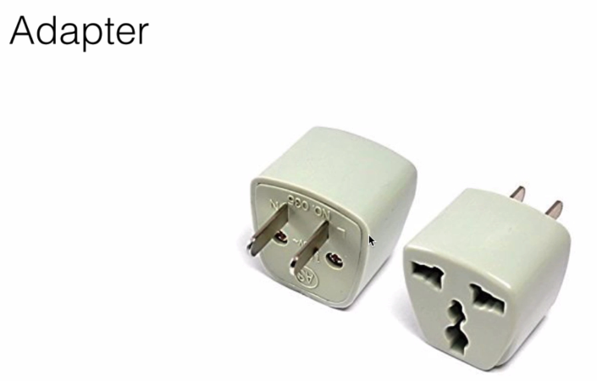

- When we have two applications communication: Similarly in the world of programming when we have two applications communicating with each other or two objects using each other and one object invokes the method off another object.
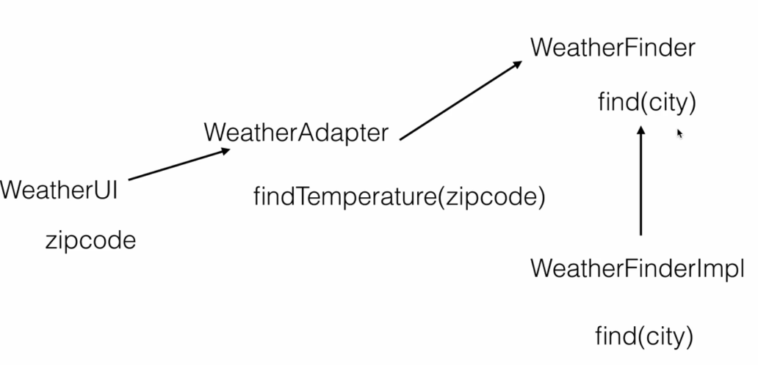

- សម្រាប់ adapter វាត្រូវតែមាន Two Class to communicate
- Weather Adapter វានៅកណ្តាលដើម្បីធ្វើការ ទំនាក់ទំនង រវាង Class: Weather UI ដែលត្រូវការ Zipcode to find the location and Class WeatherFinder វាត្រូវការ name of the city to fine the weather.

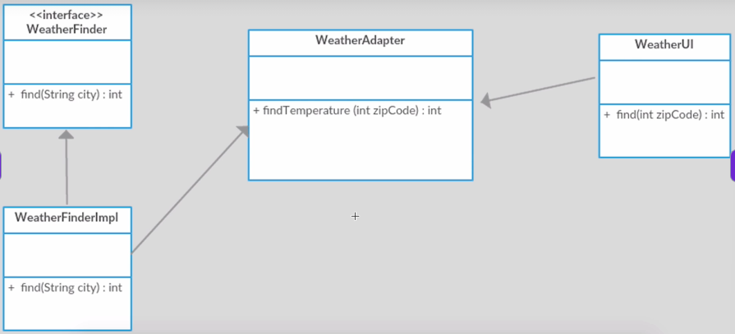

What we will design:

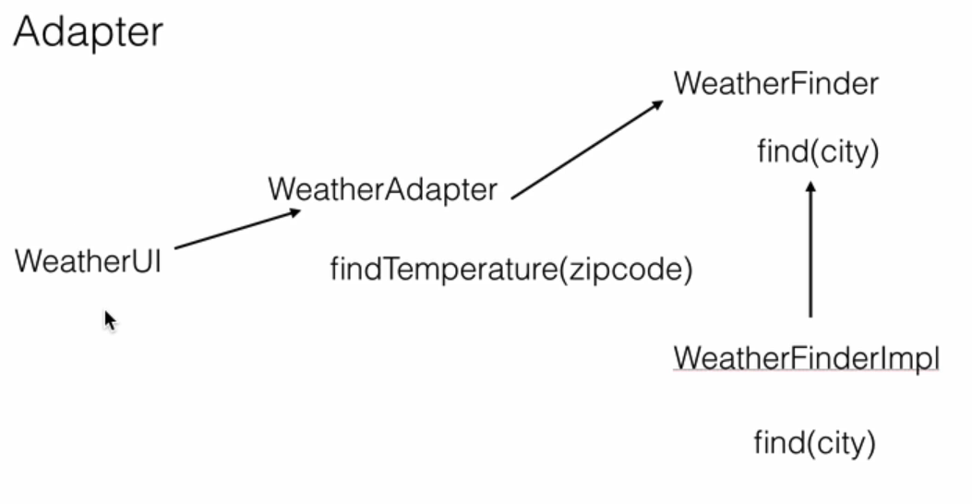

Purpose convert from String to Int: this is the adapter use for!

- Create interface: WeatherFinder
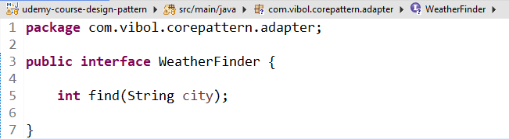

- WeatherFinderImpl

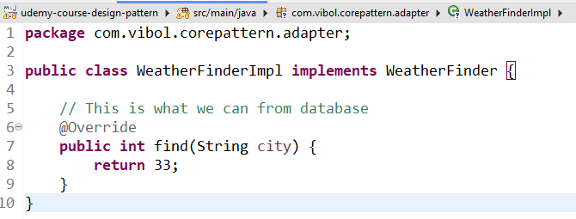

- Adapter: WeatherAdapter

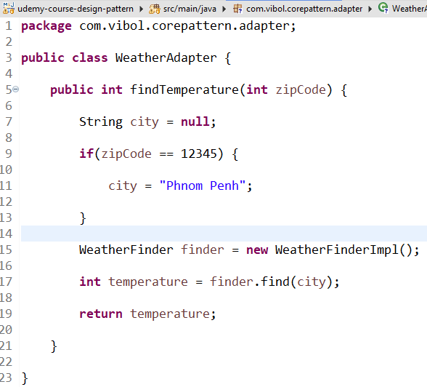

- Weather UI

